Double Drivers
Double drive cars must display a sticker provided by the organisers. The sticker should be a black ‘‘D‘‘ on white background to be placed on top of the windscreen or middle of the bodywork in front of the driver for single seaters.

Driver
Only one person is allowed in a competition car at any time during the event, including in the paddock.

Competition Numbers
Number must be clearly visible on both sides of the car. Registered Hillclimb & Sprint competitors are asked to state on their entry form their registered number. Non-registered competitors will be provided with a number by the organizers. Only the race number that you are running with on the weekend of the event is to be visible on your car. All other numbers are to be covered up or removed. The onus is on double drivers to make sure that the correct number is on the car before they get to the start line

Paddock
No competitor’s cars shall be allowed in the paddock before 7.00am on the morning of the event. There shall be no holding of spaces for any competitors. You must at all times obey the paddock marshal’s instructions. Double drivers shall be accommodated but will have to make themselves known to the paddock marshal who will have a list of the double drives. Waste bins will be provided in the paddock. A Portaloo will be in the paddock.

Practice and timed runs
Each competitor must undertake only one practice run & no practice re-runs will be allowed.
On Saturday, no competitor will be allowed on the hill after the road is closed. On Sunday, no competitor will be allowed on the hill after the road is closed.

Finish
The finish line is indicated by chequered flag boards. After crossing the finishing line competitors must reduce speed as quickly as possible within the distance of the 3-2-1 boards.

Awards
F.T.D. Overall Each Day F.T.D Saloon Each Day
1st, 2nd, 3rd in class each day
Novice Award
F.T.D. overall for the weekend

Prize Giving
Saturday’s prize giving will take place at Monks at the Pier, Ballyvaughan at 9.00pm. Sunday’s prize giving will take place in the paddock no later than 60 mins after the last car.

Final Instructions
Final instructions will be available online at www.irishhillclimb.com

Ballyvaughan Motorsport Hillclimb Weekend
Organised & Promoted by Galway Motor Club
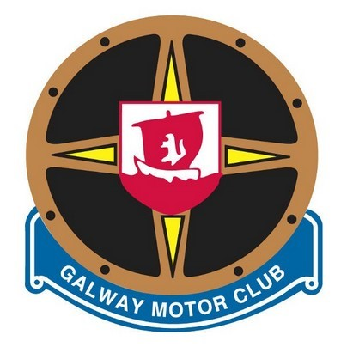
26th & 27th March 2022
Rounds 1 & 2 of the 2022
Irish Hillclimb & Sprint Championship
SUPPLEMENTARY REGULATIONS
The event is organised by Galway Motor Club and will be held under the general competition Rules of MI (incorporating the provisions of the International Sporting Code of the F.I.A.) and in accordance
with Appendix 80 and 81 of the current Motorsport Ireland Yearbook, copies of which are available on www.motorsportireland.com, and these supplementary regulations. All competitors who forward entry forms agree to be bound by these rules. Both events count as a round of the 2022 Irish Hillclimb & Sprint Championship.

MOTORSPORT IRELAND PERMIT NO: 22/022
LIST OF OFFICIALS
Motorsport Ireland Steward | Robin Taylor
Motorsport Ireland Safety Delegate | Shane Hade
Motorsport Ireland Chief Scrutineer | Pat Shiel
Event Secretary | Aisling Grimes
Entries Secretary | Catherine Connolly
Timing & Results | McAleer Timing
Ambulance | Red Cross
Rescue | Galway Bay Rally Rescue
Hill Bike Marshal | Darryl Ramsay
Paddock Marshal | Jay O’Rourke + Team
Clerk of the Course | Aiden Connolly
Deputy COC | Micheál Rodgers
Club Steward | Ray Bent
Club Safety Delegate | Bobby Clinton
Chief Marshal Patrick Curley
Event Venue: 26th & 27th March 2022, Ballyallabhan Hill,
Ballyvaughan, Co. Clare
Course Distance: 2KM
Timetable
Entries Open: On posting of the Regulations & Entry Form
Entries Close: Tuesday the 22 ^{nd} of March
Entries will be taken on a first come first served basis.
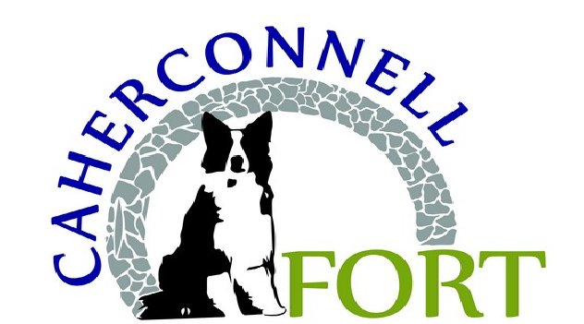

Event Timetable :
Friday 25th March 2022
Optional Scrutiny Ballyvaughan Service Station: 6.00pm – 7.30pm
Saturday 26th & Sunday 27th March 2022
Mechanical and Document Scrutiny in both Paddocks: 8.00am - 9.45am
Driver’s briefing – Paddock: | 10.00am
Road Closed Both Days: | 8.30am - 6.00pm
Practice Run: | 10.45am
1st Timed run Approx: | 11.45am
Finish Approx on both days: | 5.30pm

Entry Fee: €280 for both days €180 for a one-day entry
ENTRIES TO: CATHERINE CONNOLLY NEWTOWN,
BALLYVAUGHAN,
CO. CLARE
Contact Number: 086-0714564 PHONE BETWEEN 7PM AND 9PM
ONLY
Entry Forms must be fully completed and accompanied by a proof of Bank Transfer aached. PLEASE Reference - DRIVERS NAME
We would ask that all entries are paid Via Bank Transfer
SORT CODE: BOFIIE2D IBAN: IE97BOFI90381697748807
Alterna"vely, A cheque (not post-dated) can be made payable to
County Galway Motor Club Ltd. All cheques will be lodged on receipt.
ALL ENTRIES MUST BE POSTED BEFORE CLOSING DATE AND WILL NOT BE
ACCEPTED WITHOUT ENTRY FEE OR BANK TRANSFER PROOF INCLUDED
REMEMBER TO BRING YOUR 2022 COMPETITION LICENCE AND
VALID LOGBOOK WITH YOU
NO LICENCE = NO START NO LOGBOOK = NO
START
Class Eligibility
The onus will be on the competitor to ensure that they have been entered in the correct class. Please read the below classes carefully before you fill in your entry form
Note: CARS BEING DOUBLE DRIVEN CAN ONLY BE ENTERED INTO ONE CLASS.

2022 Class Details
Classes:
1A Production / Modified production saloons up to 1400cc. ‘Roadsters' up to 1400cc.

1B Fiat Cinquecento / Seicento as per Technical Regulations published on the MI website. 2 Production / Modified production saloons 1401 - 1650cc. ‘Roadsters' 1401-1650cc 3A Production / modified production saloons 1651cc to 2100cc. Roadsters' 1651 - 2100cc.
Front engine Sportscars up to 1650cc (car derived engines).
Front engine Sportscars up to 1200cc (motorbike derived engine).
Silhouette cars up to 1650cc.
Space-framed saloons up to 1650cc.
3B Production / modified production saloons over 2100cc. 'Roadsters' over 2100cc.
Silhouette cars from 1651cc-2100cc. Space-framed saloons over 1650cc.
Front engine Sportscars with bike derived engines over 1200cc.
Front engined Sportscars with car derived engines 1651-2100cc. 4WD Production saloons / modified saloons.
3C Silhouette cars over 2100cc Rear engined sportscars up to 2100cc Front engine sports cars with car derived engines over 2100cc. Alloy & composite saloons unlimited.
- Classic cars as per HRCA regulations (reference MI appendix 49 and FIA Appendix K). Compliance documents required: HTP, HRVIF, or Written confirmation of compliance with the HRCA regulations from an authorised representative of the HRCA.

- Formula Ford 1600 / Classic Formula Ford 1600 as per current or previous Ford Motorsport regulations.
Formula Vee as per current or previous Formula Vee regulations (Appendix 45). It is permitted to use the current Avon tyres in lieu of the Dunlop Tyres specified in previous regulations
- Single seaters up to 2100cc having only 2 valves per cylinder
Single seaters up to 1650cc having more than 2 valves per cylinder
- Single seaters over 2100cc having only 2 valves per cylinder
Single seaters over 1650cc having more than 2 valves per cylinder.
Rear engined sportscars over 2100cc
4WD cars (to cover any 4WD vehicle that is not rally/production/modified production saloon) 8a ‘1650cc 8 valve rally cars’ 2WD Rally cars up to 1650cc with not more than 2 valves per cylinder.
8b ‘1650cc 16 valve rally cars’ 2WD Rally cars up to 1650cc with more than 2 valves per cylinder.
9a ‘2100cc 8 valve rally cars’ 2WD Rally cars up to 2100cc with not more than 2 valves per cylinder.
9b ‘2100cc 16 valve rally cars’ 2WD Rally cars up to 2100cc with more than 2 valves per cylinder
10 2WD Rally Cars over 2100cc
Subject to sufficient entries these classes must apply to all Championship events.
The organising clubs may include extra classes or amalgamate classes, subject to the approval of the Hillclimb / Sprint Committee.
Rally cars must run “Rally Ready” - to include tyres, seats etc.
2022 Definitions:
Production saloon: Bodyshell as originally manufactured. Includes any steel monocoque production road car which was manufactured with more than 500 examples and has more than 2 seats.
Modified Production Saloon: (as above) bodyshell may be modified but no section may be space-framed. Any part of the bodyshell which is modified must be replaced by the same material of equal or greater thickness, wheel arch material is free and Including Mini’s with removable front section.
Roadster: (Bodyshell as above) Includes any 2-seater and 2 door steel monocoque, open or closed top. e.g. MR2 or MX5.
Alloy & composite saloon: Production saloon with more than 500 examples whose chassis is not manufactured from steel. e.g. Morgan
Spaceframe: A tubular structure which if removed would prevent the vehicle being driven.
Silhouette saloon: Chassis space-frame / alloy / composite. Bodywork to have the appearance of a large production road car with the same dimension of windscreen as that car. e.g. RT2000 Space-framed saloon: Bodyshell may be modified, Must retain the original roof, A, B & C pillars and sills of the original car and have the appearance of this car.
Sportscar: Open or closed top, with enveloping bodywork. Includes prototypes. Kit car: A vehicle that can be purchased in component form for self-assembly, capable of being road registered and that
are on sale to the general public. Including the Two-Seater or 2+2 or single seated Single seaters: Open wheeled single seater formula type racing cars.
Rally Car: Cars as per current and previous MI Rally Regulations
Turbo / supercharger: cc x 1.7 applies to all classes
Rotary engine; multiplication factor of cc x1.5 applies to all classes. The 12a engine may run in the appropriate two valve per cylinder class and all others in the appropriate over two valve per cylinder class.

